**REACT NODE PROJECT** - **WORKFORCE MANAGEMENT**

STEPS:

* Installation of MySQL
* Using backup.sql file configured wfm Database

**NODE- API calls:**

* Api call for Listing Employee data from employee, skill and skillmap table in Manager Home Screen.

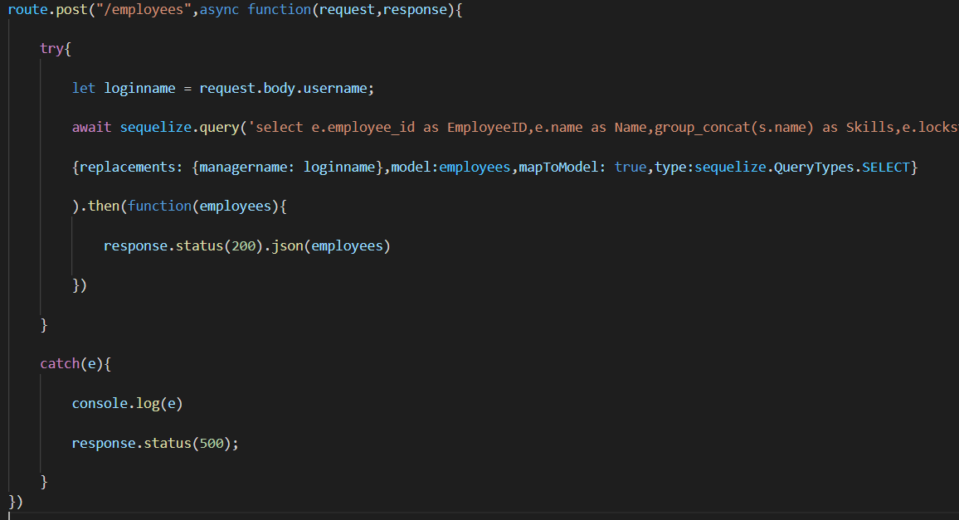

* From the Manager Home Screen after requesting the employee the status is updated as “request_waiting” in Employee table
* The employee data and the requested date etc are inserted in the softlock table
* Below Api calls are to update in employee and insert in softlock table

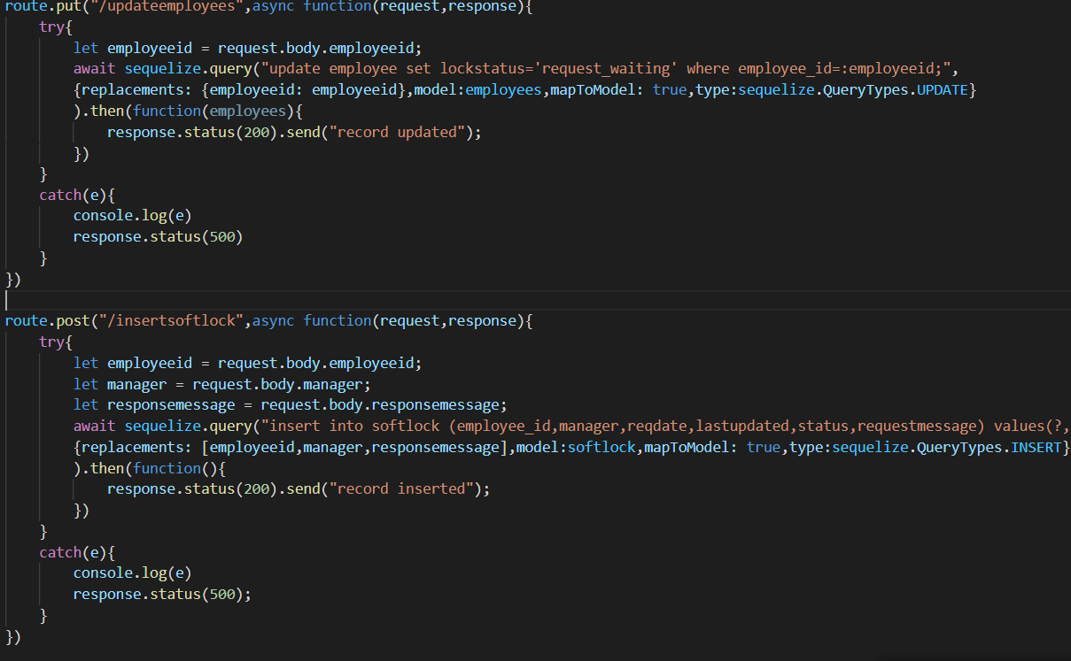

* This Api call is to list the requested employee data in WFM manager Home Screen

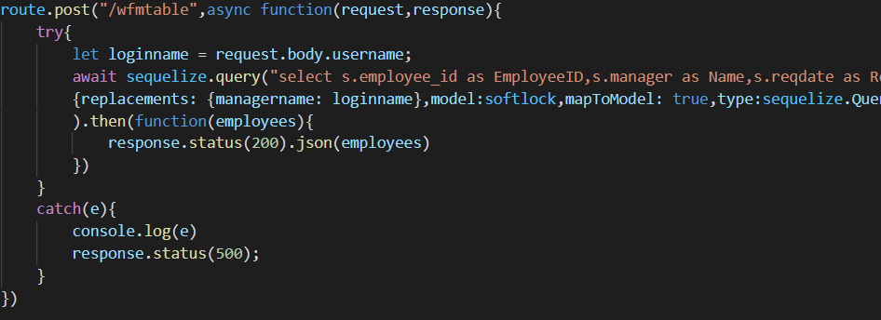

* Below two Api calls are to update lockstatus in employee and softlock table

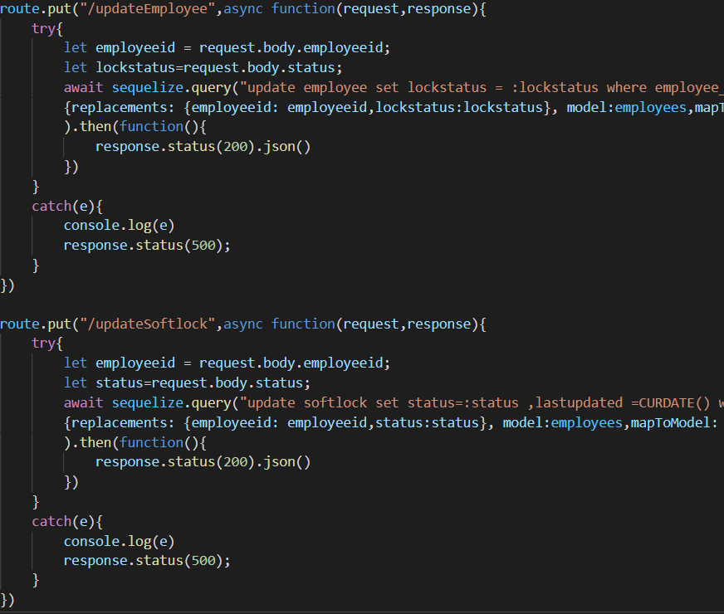

**REACT UI - OUTPUT SCREENS**

**Manager Home Screen**

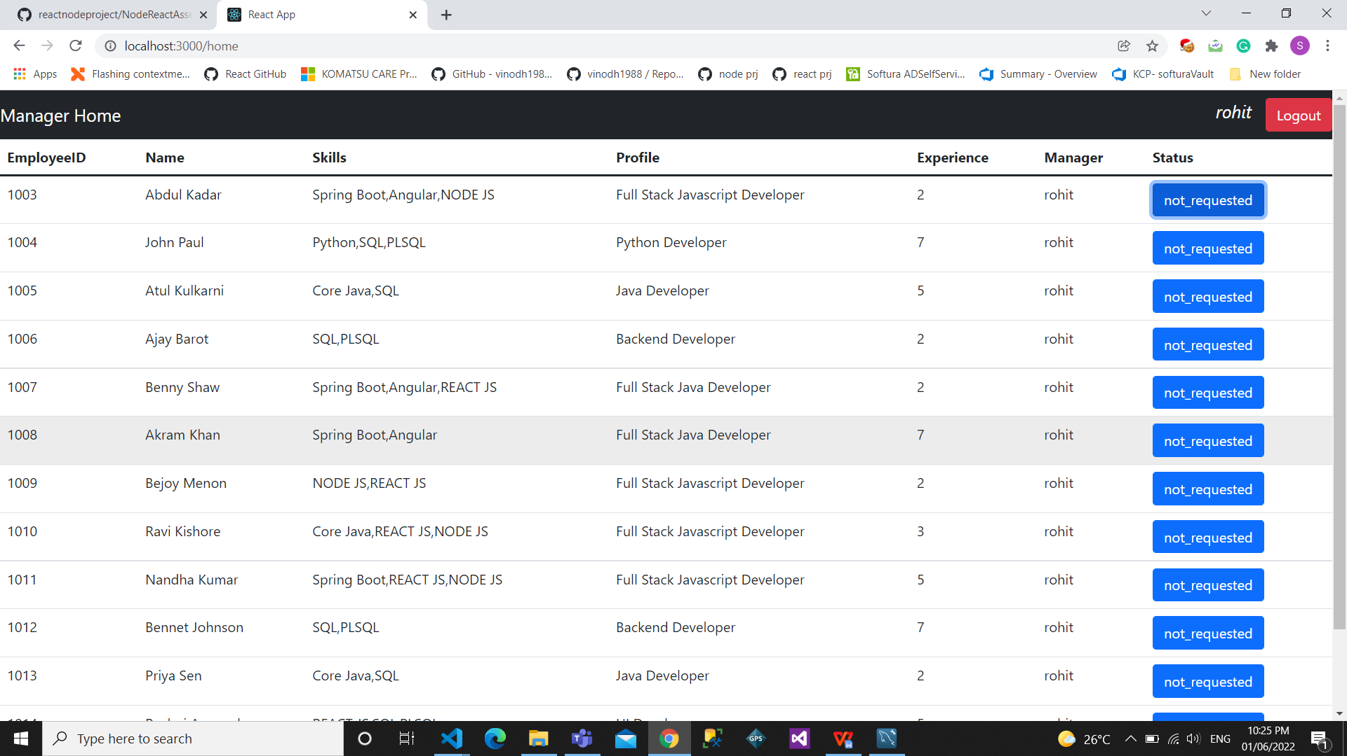

**SoftLockRequest** :

(requested for empolyee id 1003)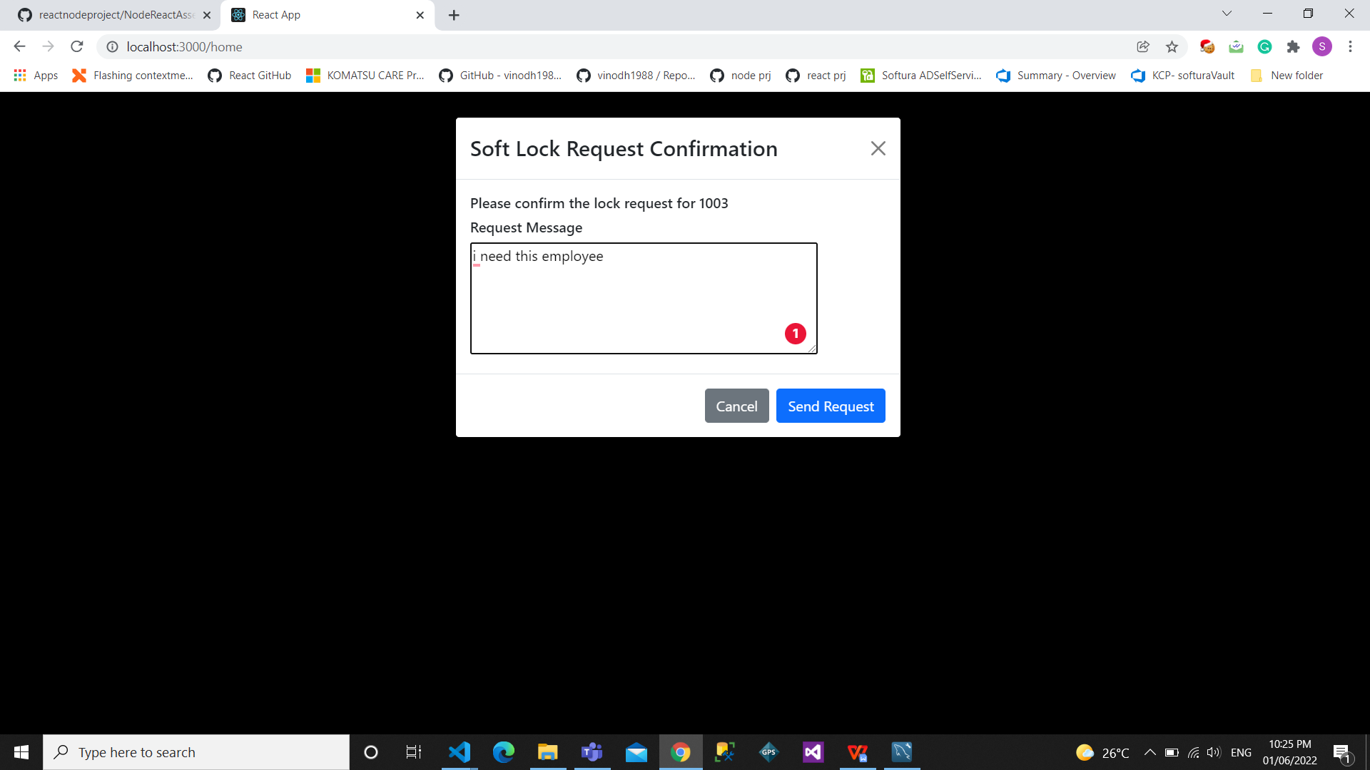

After this send request in **WFM Manager Home** (logged in as lokesh wfm manager

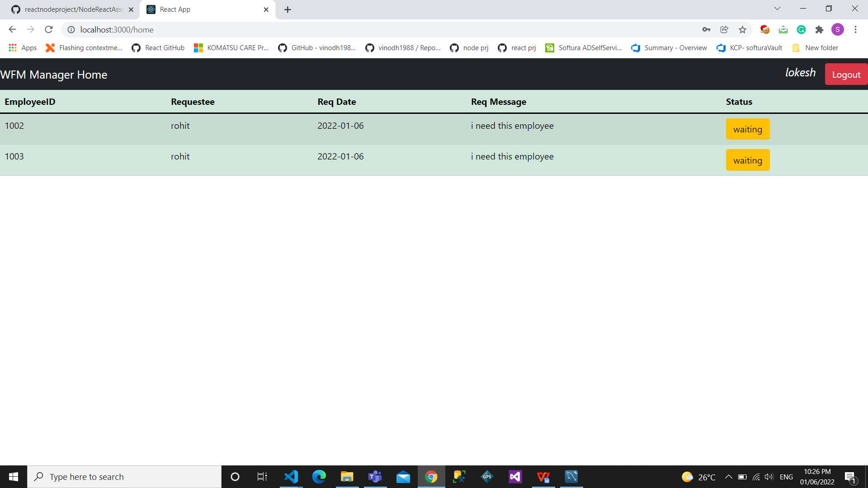

**SoftLock Request Confirmation:**

Accepted or Rejected status will be send to the employee table

